**I REVOLUTION:A DATA DRIVEN EXPLORATION**

**OF APPLE’S IPHONE IMPACT IN INDIA**

1.Introdution:

The iphone is a smartphone made by Apple that combines a computer,ipad,digital camera and cellular phone into one device with a touchscreen interface

The iphone runs the IOS operating system, and in 2021 when the iphone 13 was introduced, it offered up to 1TB of storage and as 12-magapixel camera

2.Empathy Map:

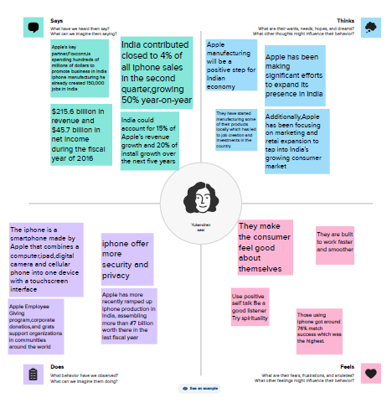

3.Brainstorming:

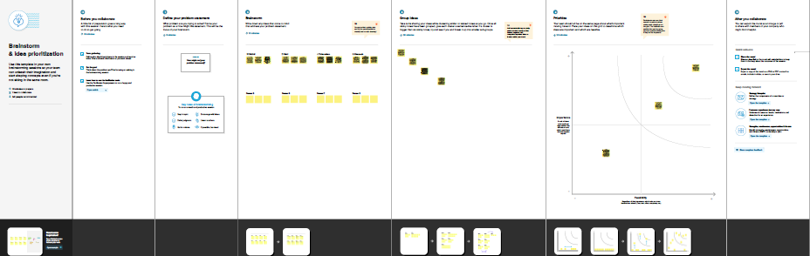

4.Advantage & Disadvantage

4.1 Advantage:

**1. User-Friendly Interface:** The iPhone has an intuitive user interface that makes it easy to navigate. The touch screen interface is easy to use, and the iPhone’s smooth operating system is simple to learn and use.

**2. High-Quality Display:** The iPhone’s Retina display is one of the best in the market. With a density of over 300ppi, pictures and videos appear clear and crisp. This high-quality display is perfect for streaming TV shows, movies, and graphic-intensive games.

**3. Advanced Camera**: iPhone devices have some of the best cameras in the market. They have been known to produce stunning images and videos of the highest quality. They also come with image stabilization features that help reduce blur and take better pictures in low light.

**4. Apps Ecosystem**: The App Store is unparalleled in terms of access and ease of use. With millions of apps to choose from, users have access to a plethora of tools, games, and services that cater to their needs.

**5. Seamless Integration with other Apple devices**: The iPhone has a seamless integration with other Apple devices such as MacBook, iPad, and Apple Watch. It allows users to access and transfer data across multiple devices.

4.2 Disadvantage:

**1. Cost:** The iPhone is one of the most expensive smartphones on the market. High-end models can cost over $1000, which makes it a luxury item for many people.

**2. Non-Removable Battery**: The iPhone’s batteries are non-removable, which means that users cannot replace them. This can be a disadvantage for people who rely heavily on their phones and have to replace them regularly.

**3. Limited Customization**: One of the disadvantages of the iPhone is that it has limited customization options. Unlike Android devices, users cannot customize their phone’s interface, which can be a disadvantage for some people.

**4. No Expandable Storage**: Another disadvantage of the iPhone is that it has no expandable storage options. Users have to purchase iPhones with larger storage capacities, which can be costly.

In conclusion, the iPhone has been a game-changer in the technological world. It has revolutionized the way people communicate and access information. However, its advantages and disadvantages must be weighed carefully by potential buyers. Ultimately, the choice of whether to purchase an iPhone depends on the user’s preference, needs, and budget

**5.Conclusion**

Apple's stellar performance of late is best reflected in how the iPhone has ground out a bigger share of India's highly competitive and price-sensitive smartphone market. Apple sold 3.2 million iPhones in 2020, equalling its 2017 record and giving it a 2.13 per cent market share, according to CyberMedia Research (CMR)